1. **LITERATURE REVIEW AND PROBLEM IDENTIFICATION**
   1. **PROBLEM IDENTIFICATION**

As All-Terrain Robots solve most of the problems involving search and rescue, they are very helpful for treating problems in urban areas like searching for defects in sewage pipes, search for rescue operations in the rubble of a catastrophe, secret surveillance etc. But the use of All-Terrain Robots in real life is very scarce. Besides military, only developed places of developed countries adapted these robots. The main reason behind this is that all the All-Terrain Robots, which are commercially available, are either very costly and/or have a complicated design. This would make it difficult for a common man to either buy the robot or fathom the design and control the robot.

This project focuses on these key factors and help contribute to the development for easily adaptation of All-Terrain Vehicles.

* 1. **OBJECTIVES OF PROJECT**

As described in Section 2.1, the main problem behind lack of proliferation of All-Terrain Vehicles is the cost and the complexity. So our objectives are to develop a robust All-Terrain Vehicle that has the following key features: -

* Portability – To weigh less than 5kg so that it can be carried easily by a single person;
* Mobility – To be able to climb stairs and maneuver in rough terrains;
* Versatility – To be adapted easily by public, by designing the parts with less complexity which makes assembling the 3D printed parts simple.

With the several different objectives in mind and the will to produce a versatile product, a literature survey lasting one month was carried out mostly via internet. Some of the previous projects from the college library were also considered.

* 1. **TYPES OF ALL-TERRAIN ROBOTS**

Many robots from commercial companies, research institutes, universities, government agencies were evaluated and they were broadly categorized based on their locomotion mechanism into four types of robots namely, Legged, Wheeled, Tracked and Re-configurable robots.

* + 1. Legged Robots

Most man-made vehicles today travel on wheels and for good reason that wheels are much easier to construct and control. However, legs have distinct advantages over wheels. The biggest advantage is in transverse-ability and efficiency. Legged robots have a unique ability to:

* Isolate their body from terrain irregularities
* Avoid undesirable footholds
* Regulate their stability
* Achieve energy efficiency

These advantages are very desirable in modern robotics, and therefore a lot of research is being put into creating robots that can walk. The most challenging task in designing a legged robot is to create a system that can generate the proper gait.

There are many legged robotics projects that can be found in the internet. There is great research interest in the robotics community on two-legged robots (primarily humanoid robots) but they are excluded from this survey.

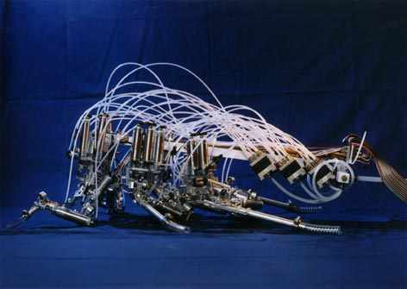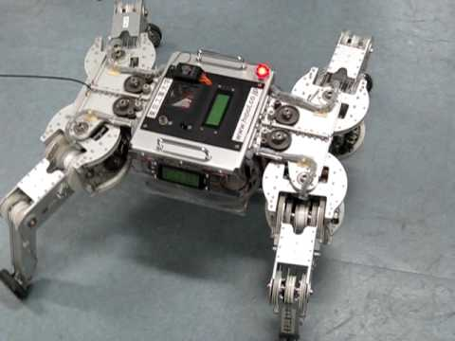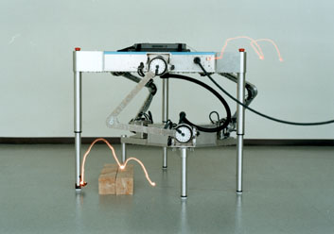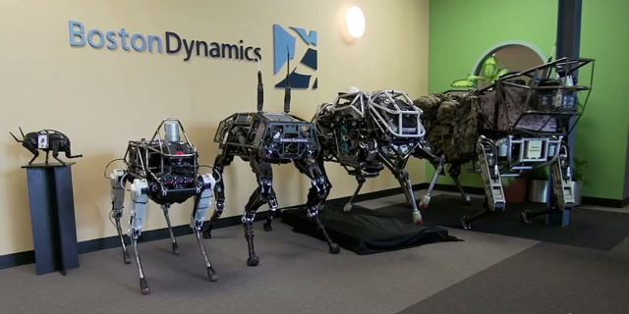

Figure 2.1: Legged Robots

1. Boston Dynamics robots, from left to right, Little Dog (on pedestal), Spot, BigDog, WildCat and LS3
2. Parawalker from Tokyo Institute of Technology
3. Robot III from Case Western Reserve University
4. Titan VIII from Tokyo Institute of Technology

(d)

(c)

(b)

(a)

Legged robots, such as Little Dog, Spot, BigDog, WildCat and LS3 of Boston Dynamics and Parawalker and Titan VIII (see Figure 2.1 (a), (b) and (d)), are developed for their ability to move in outdoor environment with obstacles or rubble, while others like Robot III (see Figure 2.1 (c)), are developed to study gait patterns of insects or animals.

Table 2.1: Technical Specifications of Titan VIII

|  |  |
| --- | --- |
| Dimension | 400mm x 600mm x 250mm |
| Number of Legs | 4 |
| Degree of Freedom | 12 (Each leg has 3 D.O.F) |
| Weight | 19kg (Including motor driver. Not including computer and battery) |
| Payload | 5 to 7kg |
| Limitation of walking velocity | 0.3m/s (Duty Factor =0.75)  0.9m/s (Duty Factor) =0.5) |

* + 1. Wheeled Robots

Wheeled robots are robots that navigate around the ground using motorized wheels to propel themselves. This design is simpler than using treads or legs and by using wheels they are easier to design, build, and program for movement in flat, not-so-rugged terrain. They are also more well controlled than other types of robots. Disadvantages are that they cannot navigate well over obstacles, such as rocky terrain, sharp declines, or areas with low friction. Wheeled robots are most popular among the consumer market, their differential steering provides low cost and simplicity. Robots can have any number of wheels, but three wheels are sufficient for static and dynamic balance. Additional wheels can add to balance; however, additional mechanisms will be required to keep all the wheels in the ground, when the terrain is not flat.

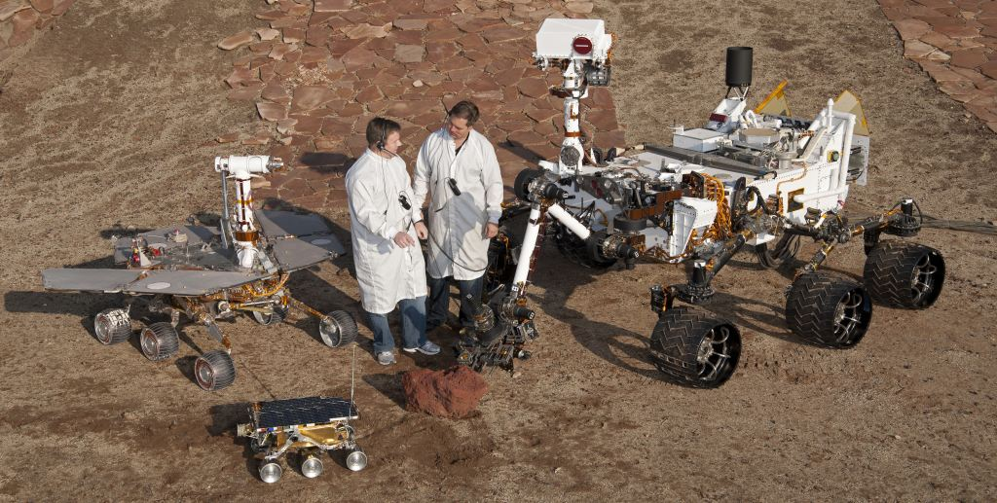 Most wheeled robots use differential steering, which uses separately driven wheels for movement. They can change direction by rotating each wheel at a different speed. There may be additional wheels that are not driven by a motor these extra wheels help keep it balanced.

(a)

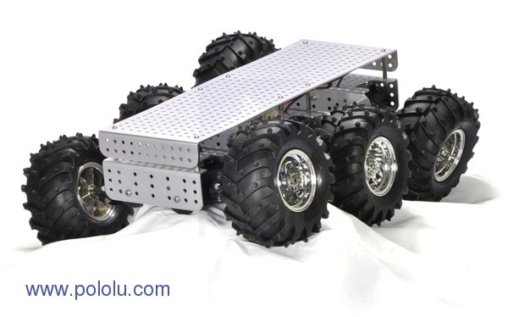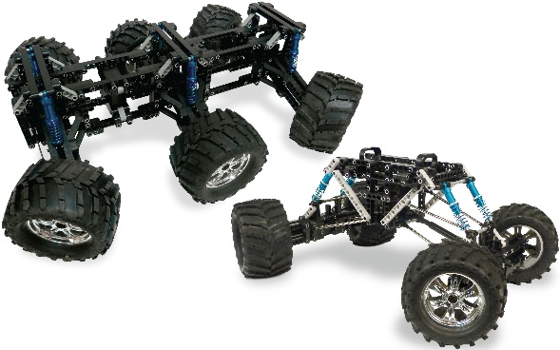

(c)

(b)

Figure 2.2: Wheeled Robots

1. NASA Mars Rovers; Front: Sojourner, 65cm (2.13ft.) long; Left: Opportunity, 1.6m (5.2 ft.) long; Right: Curiosity, 3m (9.8ft.) long.
2. Minds-i Super Rover Robot from X-CAL
3. Wild Thumper 6WD by Pololu

Wheeled robots are the most common types of robots available. Their design can be very simple to serve as platforms to carry payload, for example, explosive and ordnance disposal robots like Wild Thumper (see Figure 2.2 (c)). Their design can also be very complicated, such as NASA’s Mars Rovers (see Figure 2.2 (a)), to serve as platforms for planetary exploration.

Table 2.2: Technical Specifications of Wild Thumper 6WD

|  |  |
| --- | --- |
| Dimension | 420mm x 300mm x 130mm |
| Number of wheels | 6 |
| Ground clearance | 60mm at 2.5kg payload |
| Weight | 2.7kg |
| Payload | 5 to 7kg |
| RPM | 350 for 34:1 gearbox  160 for 75:1 gearbox |

* + 1. Tracked Robots

Tracks are a comparatively rare and largely unsuccessful form of locomotion on robots, consisting of treads or caterpillar tracks. They are usually rubbery, to gain traction on the arena floor. Tracks in general, particularly treads, are not to be confused with simple drive chains, which merely provide drive for a robot. Tracks stretch back a long way, as far back as Mortis in Series 1. Since then numerous competitors and House Robots used them, but they were a dying breed.

*Advantages*

* Tracks gave more traction on the arena floor than wheels, leaving them with more resistance to being pushed.
* Tracks ran down the whole sides of a robot, and if they are concealed well enough, can fend off flippers from these angles.

*Disadvantages*

* Tracks are more likely to break than wheels from spikes and axes and are easily dislodged
* They are more difficult to repair or replace than wheels.

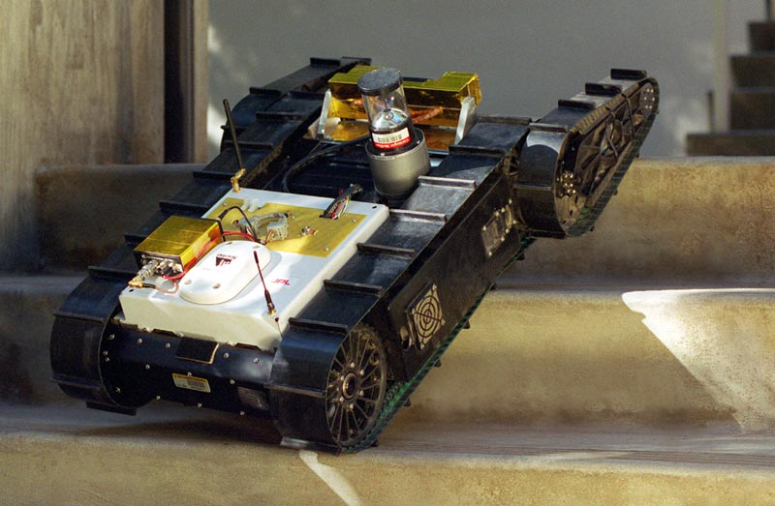

(a)

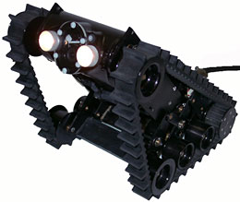

(b)

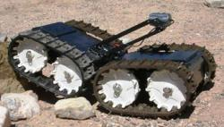

(c)

Figure 2.3: Tracked Robots

1. Urbie from iRobot
2. Micro B+VGTV from Inuktun
3. Lurch from Sandia

Tracked robots are mostly commercial than research oriented, for example, Urbie from iRobot (see Figure 2.3 (a)) is developed for urban reconnaissance and surveillance while MicroVGTV (see Figure 2.3 (b)) is developed for piping inspection as well as urban search and rescue. Lurch (see Figure 2.3 (c)) is a research robot developed for terrain exploration.

Table 2.3: Technical Specifications of Wild Thumper 6WD

|  |  |
| --- | --- |
| Dimension | 625mm x 508mm x 290mm |
| Weight | 18kg (without sensors) |
| Speed | 1.6m/s |
| D.O.F for Flipper | 360° |
| Maximum Gradient | 45° |

* + 1. Re-Configurable Robots

Self-reconfigurable robots are constructed of robotic modules that can be connected in many different ways. These modules move in relationship to each other, which allows the robot as a whole to change shape. This shapeshifting makes it possible for the robots to adapt and optimize their shapes for different tasks. Thus, a self-reconfigurable robot can first assume the shape of a rolling track to cover distance quickly, then the shape of a snake to explore a narrow space, and finally the shape of a hexapod to carry an artifact back to the starting point. The field of self-reconfigurable robots has seen significant progress over the last twenty years, and this book collects and synthesizes existing research previously only available in widely scattered individual papers, offering an accessible guide to the latest information on self-reconfigurable robots for researchers and students interested in the field.

Polybot and polypod are reconfigurable robots that are highly versatile, which are made of one or two type of repeated modules respectively. They have the ability to reconfigure themselves to whatever shape that best suits the current tasks. 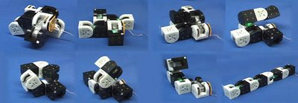

(a)

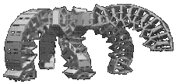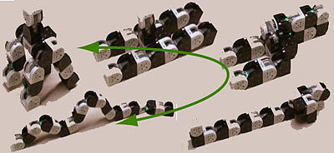

(c)

(b)

Figure 2.4: Self Reconfigurable Robots

1. MTRAN-III by Haruhisha Kurokawa
2. Polypod from PARC
3. Polybot from PARC
   1. **COMPARISON FACTORS OF ROBOTS**

Five factors, namely terrain capabilities, payloads, stability, speed and complexity are used independently to compare the four types of robots. Though the in-depth comparison is done using a technical specification of the robots found in the survey, a simple comparison matrix (see Table 2.4) is used to identify the best locomotion mechanism.

* + 1. Terrain Capabilities

Terrain capabilities refer to the ability of the robot to traverse on various type of terrains such as flat ground, grassland and rubble, and to overcome obstacles such as step, ramp, ditch and staircase. In comparison, legged robots will have the best abilities followed by re-configurable robots; both types of robots are able to traverse on the various types of terrain and overcome most of the obstacles. Tracked robots have the ability to traverse in most terrain but unable to overcome most obstacles. However, with the addition of one or two pairs of articulated tracks, they are able to traverse on most terrain and overcome most obstacles. Wheeled robots only have the ability to traverse on flat terrain.

* + 1. Payloads

Payloads refer to the additional weight that can be carried by the robot. Both wheeled and tracked robots can support high payloads while legged and reconfigurable robots can only support low payloads. Reconfigurable robots can only carry payloads that can be packed inside them.

* + 1. Stability

Stability is the ability of the robot to remain controllable during movement or obstacle negotiation and it is usually related to the contact area of the robot to the terrain. Better stability means that the robot has a lower risk to be overturned or trapped by an obstacle, it allows more payloads that can be carried by the robot. Tracked robots have excellent stability while wheeled robots have good stability due to their large contact area to the terrain. Similarly, reconfigurable robots have moderate stability while legged robots have poor stability.

* + 1. Speed

Speed determines how fast the robot can move from place to place and how far the robot can move. Wheeled robots have the fastest speed followed by tracked robot while reconfigurable robots and legged robots had almost comparable speed.

* + 1. Complexity

Complexity refers to design and engineering efforts required to build such a robot. It also determined the approximate cost of such a robot. Reconfigurable robots are the most complex (due to the need for modularity which leads to redundancy), followed by legged robots, tracked robots and lastly wheeled robots.

* 1. **COMPARISON OF VARIOUS TYPES OF LOCOMOTION**

Table 2.4: Comparison Table Using Various Comparison Factors

|  |  |  |  |  |
| --- | --- | --- | --- | --- |
| **Factors\Type of Robot** | **Wheeled** | **Tracked** | **Legged** | **Reconfigurable** |
| **Terrain Capabilities** | *Moderate* | Moderate | Good | Good |
| **Stability** | *Good* | Excellent | Poor | Moderate |
| **Speed** | *Excellent* | Good | Moderate | Moderate |
| **Payloads** | *High* | High | Low | Low and Limited |
| **Complexity** | *Low* | Moderate | High | Very High |

The comparison factors summarized in the above table show that though the terrain capabilities of wheeled robots are moderate, it is identified that wheeled robots are less complex when compared to any type of robot. Since one of our objective is to make the design simple so that it can be easily adapted by public, wheeled robots are given the high preference.

However, the design is achieved through an inspiration from Rocker Bogie Mechanism which is implemented in Mars rover – Curiosity and a GOAT research carried mutually by Carnegie Mellon University and Georgia Tech University and many other independent works which are referenced in the last chapter.

* 1. **TYPES OF ADDITIVE MANUFACTURING TECHNIQUES**

There are many different kinds of additive manufacturing techniques and research is still carried on to bring even more techniques to either soothe the process or decrease the cost or make the technique applicable to wide range of materials. To decrease the vagueness, the literature survey is carried out on most used 3D printing techniques which are SLA, FDM, MJM, 3DP and SLS. These are briefly explained.

* + 1. Stereo-Lithography - SLA

Very high end technology utilizing laser technology to cure layer-upon-layer of photopolymer resin (polymer that changes properties when exposed to light).

The build occurs in a pool of resin. A laser beam, directed into the pool of resin, traces the cross-section pattern of the model for that particular layer and cures it. During the build cycle, the platform on which the build is repositioned, lowering by a single layer thickness. The process repeats until the build or model is completed and fascinating to watch. Specialized material may be needed to add support to some model features. Models can be machined and used as patterns for injection molding, thermoforming or other casting processes.

* + 1. Multi-Jet Modelling - MJM

Multi-Jet Modeling is similar to an inkjet printer in that a head, capable of shuttling back and forth (3 dimensions-x, y, z)) incorporates hundreds of small jets to apply a layer of thermos-polymer material, layer-by-layer.

* + 1. Selective Laser Sintering - SLS

Somewhat like SLA technology Selective Laser Sintering (SLS) utilizes a high powered laser to fuse small particles of plastic, metal, ceramic or glass. During the build cycle, the platform on which the build is repositioned, lowering by a single layer thickness. The process repeats until the build or model is completed. Unlike SLA technology, support material is not needed as the build is supported by un-sintered material.

* + 1. Fused Deposition Modelling - FDM

Process oriented involving use of thermoplastic (polymer that changes to a liquid upon the application of heat and solidifies to a solid when cooled) materials injected through indexing nozzles onto a platform. The nozzles trace the cross-section pattern for each particular layer with the thermoplastic material hardening prior to the application of the next layer. The process repeats until the build or model is completed and fascinating to watch. Specialized material may be need to add support to some model features. Similar to SLA, the models can be machined or used as patterns.

With this survey of various types of 3D printing technologies, to design a low cost and robust robot the process of FDM is selected. This is because FDM is the easiest form of 3D printing compared to other 3d printing technologies and the services for FDM are available in cities and are increasing in number which makes it easy for a common man to get the parts printed.

Thus, the 3d models are designed so that they are easily understood and easily assembled and also involve less complexity during FDM, thereby reducing manufacturing costs.